Steps to configure Proxy

Forcepoint Proxy authenticate every user with DOP Active Directory to permit internet access.
- If user is using AD credentials, he will by default granted access to use proxy with following proxy settings.
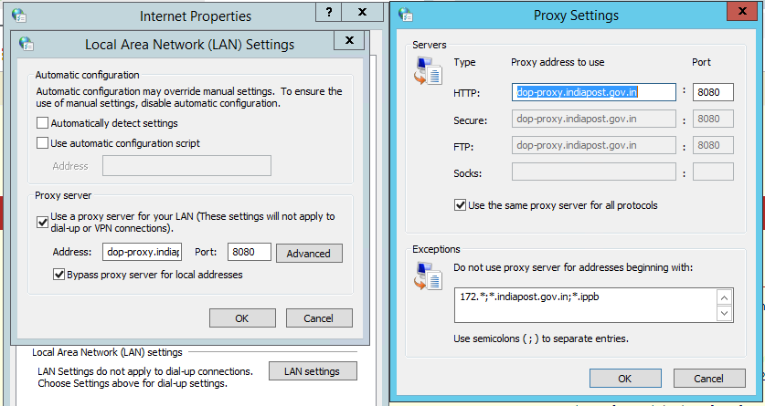

- If user is logged in with local account kindly follow below steps to configure proxy settings-

- Configure proxy settings as stated in below screenshot. Proxy IPs that can be used are 172.17.64.29/30 port number 8080 or dop-proxy.indiapost.gov.in

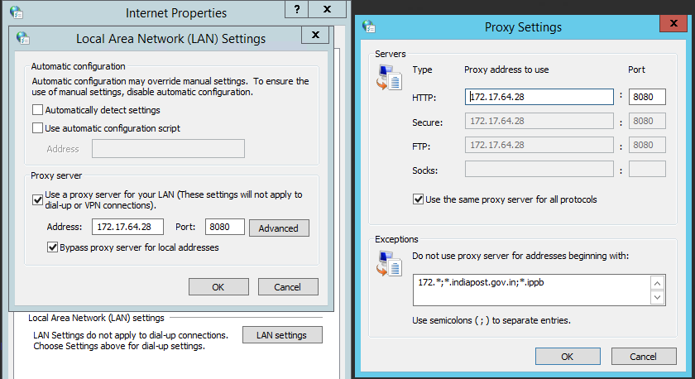

- Open browser, try accessing internet a prompt will appear for credentials.
- Enter Active Directory domain/ Email Password credentials only and start accessing internet.

How to Change Active Directory Domain/ Email Password
To reset active directory/ Email password, kindly follow below steps:
- Login to im.indiapost.gov.in/identity with SSO credentials. In case of user don’t know SSO password, please connect with RDA or raise a servicedesk ticket for the same.
- After login, go to Home -> Change Active Directory/ Email Password as shown below.

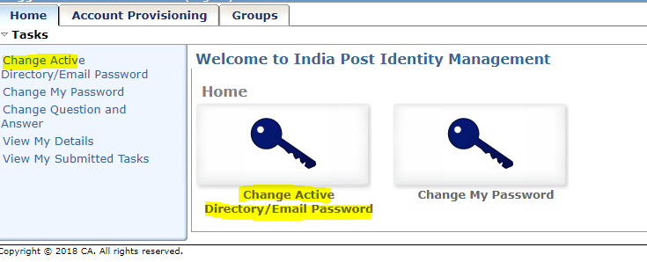

- Enter password as per given guidelines mentioned below.

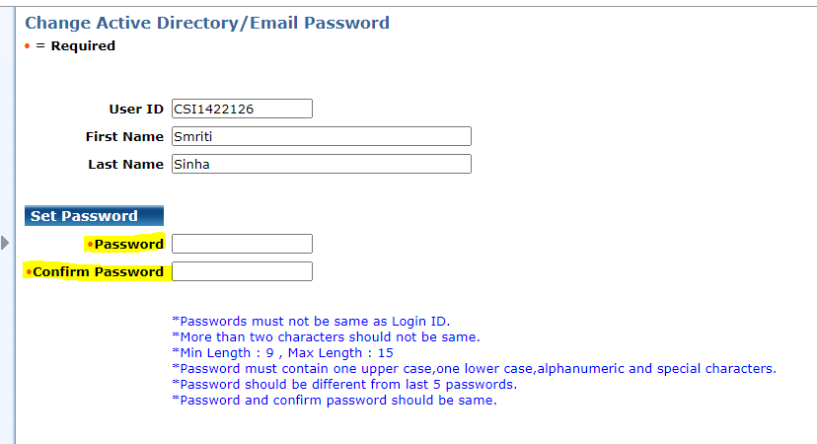

- After entering password, click on the submit button as shown below.

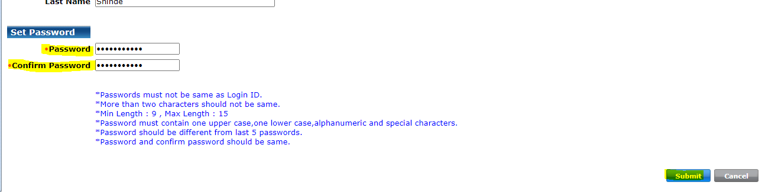

- Task will be applied to the system. Moreover, you can check task status in Home -> View my submitted task. With proper date filter search for the task and you can see the status of submitted task.

- Once task gets completed, AD password will be reset.
- In case of user face any challenge while resetting AD password, please connect with your respective RDA or raise a servicedesk ticket for the same.

